# Terraform - basic syntax

# 

## **Tutorial**

## **Tutorial**

**Azure**

create example directory and move to it

**$ mkdir example && cd $_**

create files main.tf variables.tf outputs.tf

**$ touch main.tf variables.tf outputs.tf**

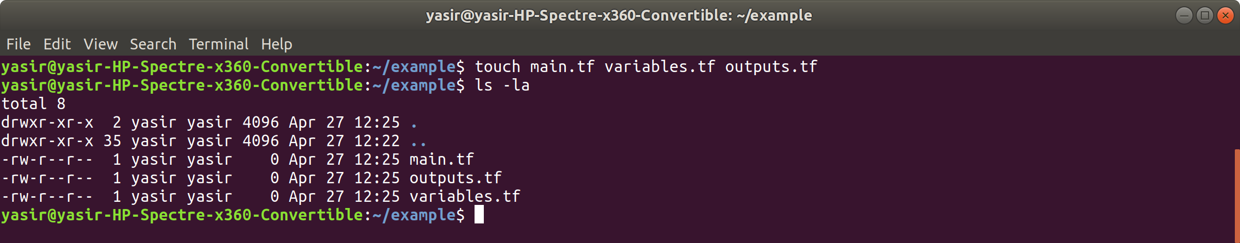

Define the provider and resource to use, so edit the main.tf file

**$ vim main.tf**

add the following

# Configure the Azure Provider

provider "azurerm" {

version = "=2.0.0"

features {}

}

# Create a resource group

resource "azurerm_resource_group" "example" {

name = "example-rg"

location = "East US 2"

}

# Create a virtual network within the resource group

resource "azurerm_virtual_network" "example" {

name = "example-network"

resource_group_name = azurerm_resource_group.example.name

location = azurerm_resource_group.example.location

address_space = [vpc_address_space]

}

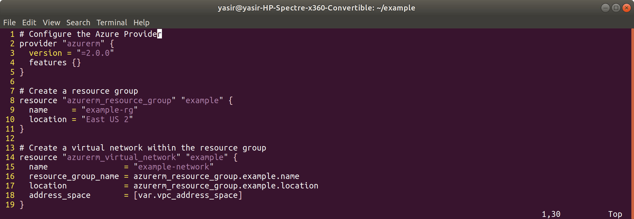

define a variable

**$ vim variables.tf**

type in the following

variable “vpc_address_space” {

default = “10.0.0.0/16”

}

**$ vim variable.tf**

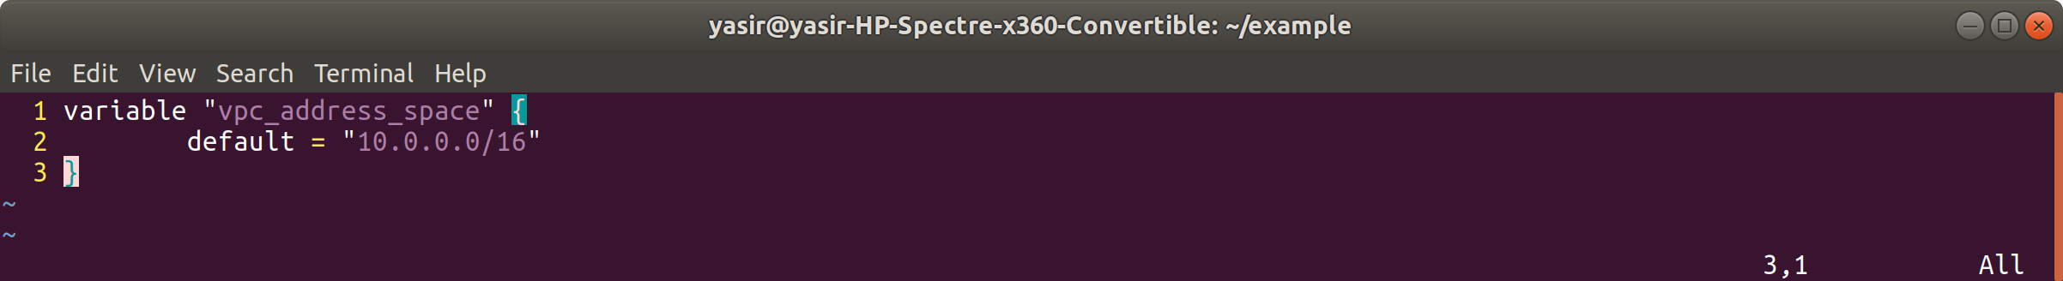

Edit output file, type in the following

output “vpc_id” {

value = azurerm_network.example.id

}

**$ vim outputs.tf**

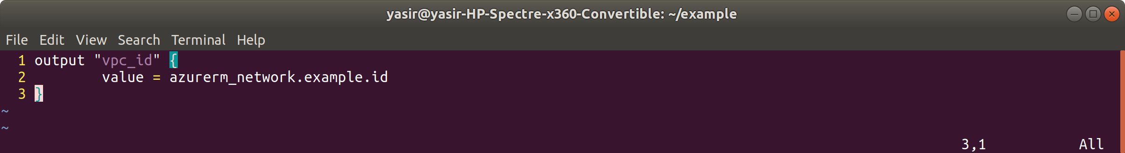

Initialise terraform

**$ terraform init**

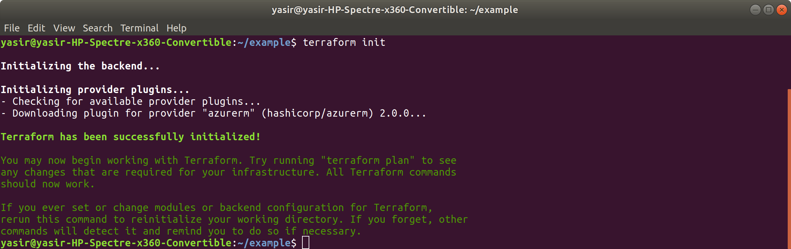

Now validate

**$ terraform validate**

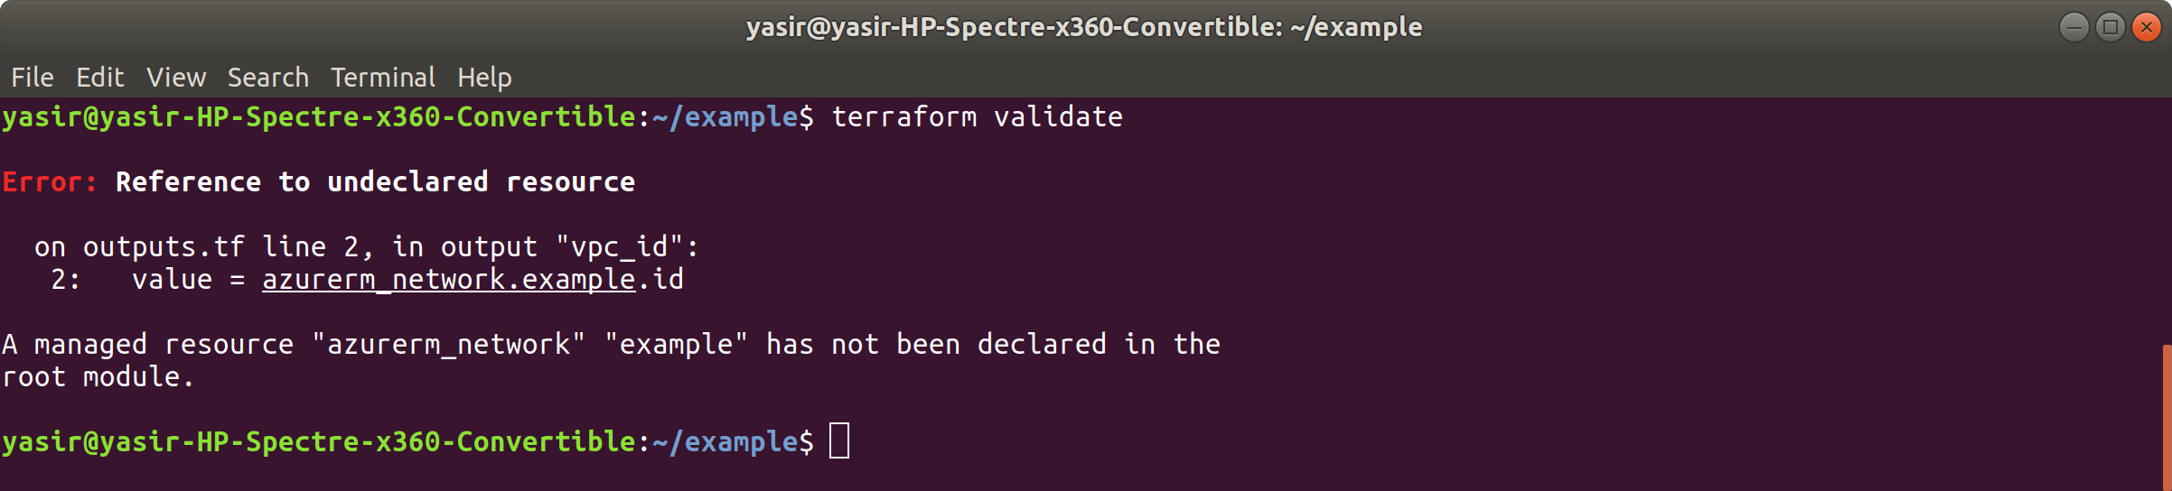

in outputs.tf file change “azurerm_network” to “azurerm_virtual_network”

**$ vim outputs.tf**

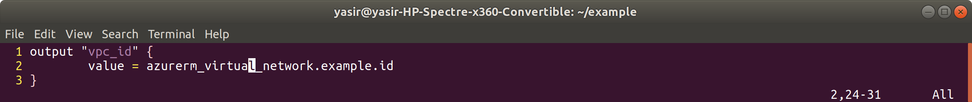

**$ terraform validate**

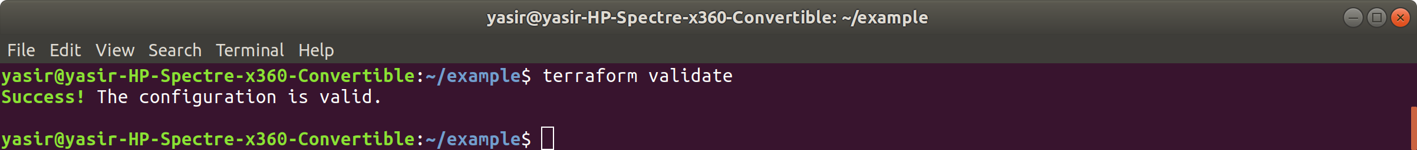

Now list the plan

**$ terraform plan**

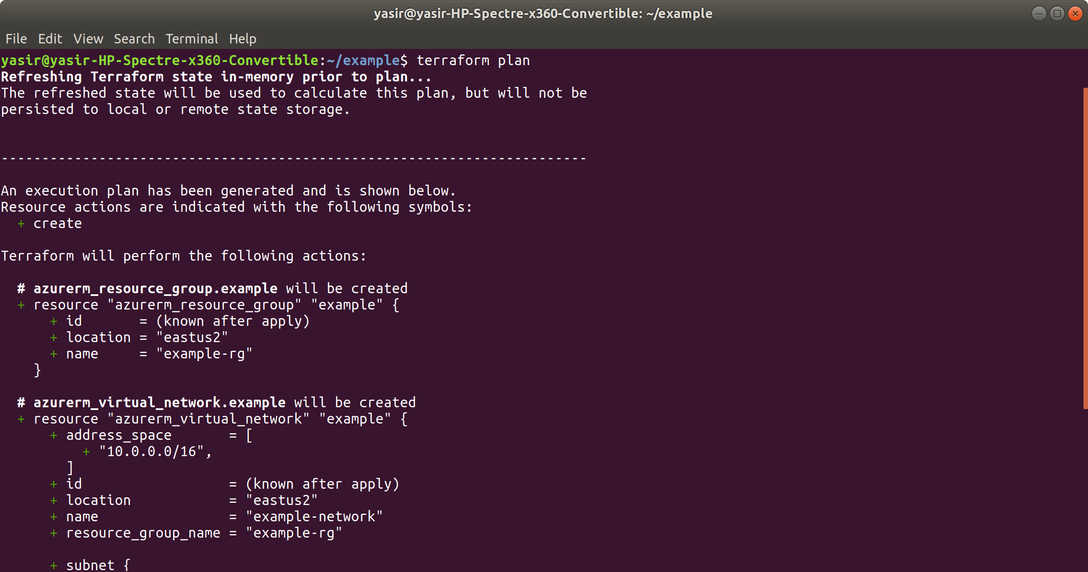

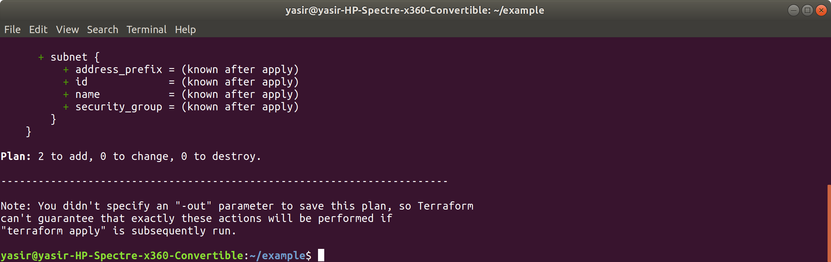

Save the plan to a file

**$ terraform plan --out=plan1**

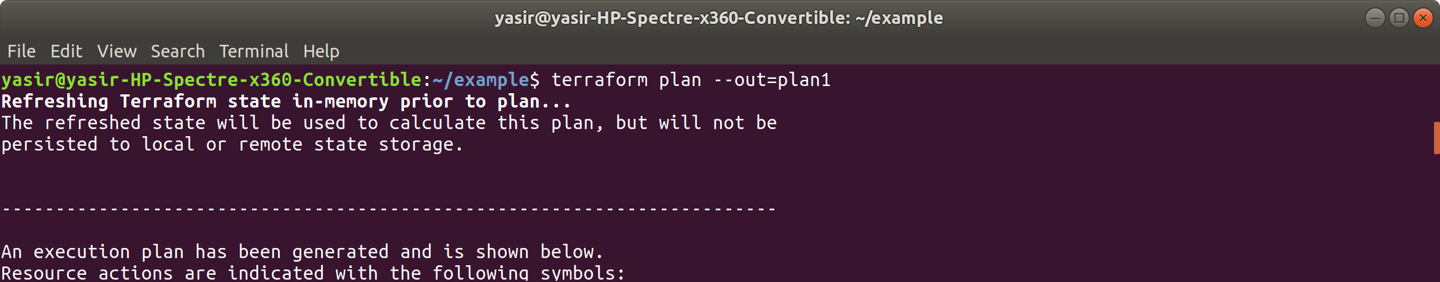

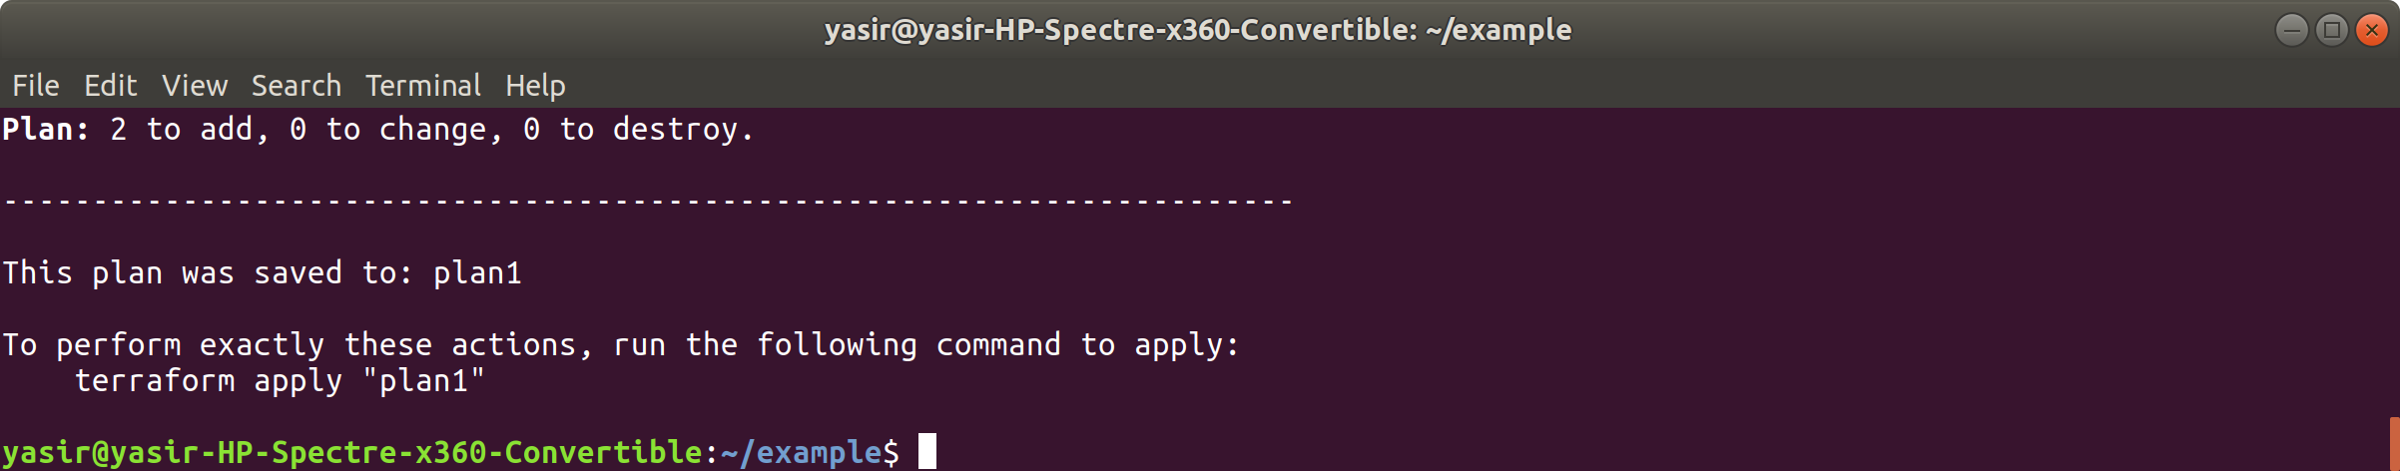

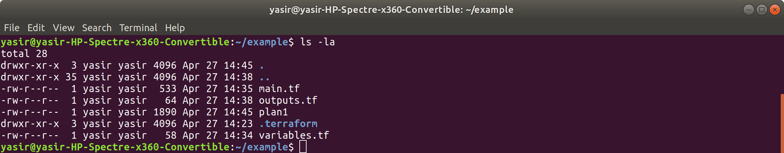

**$ terraform apply**

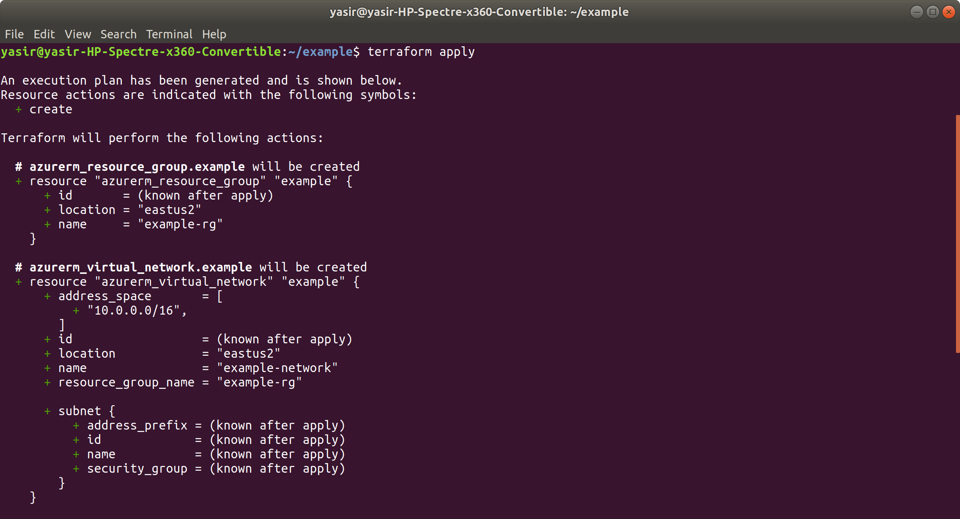

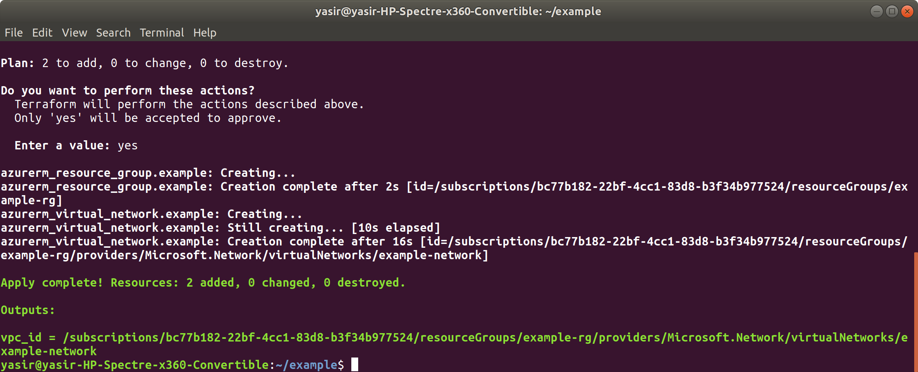

**$ terraform output vpc_id**

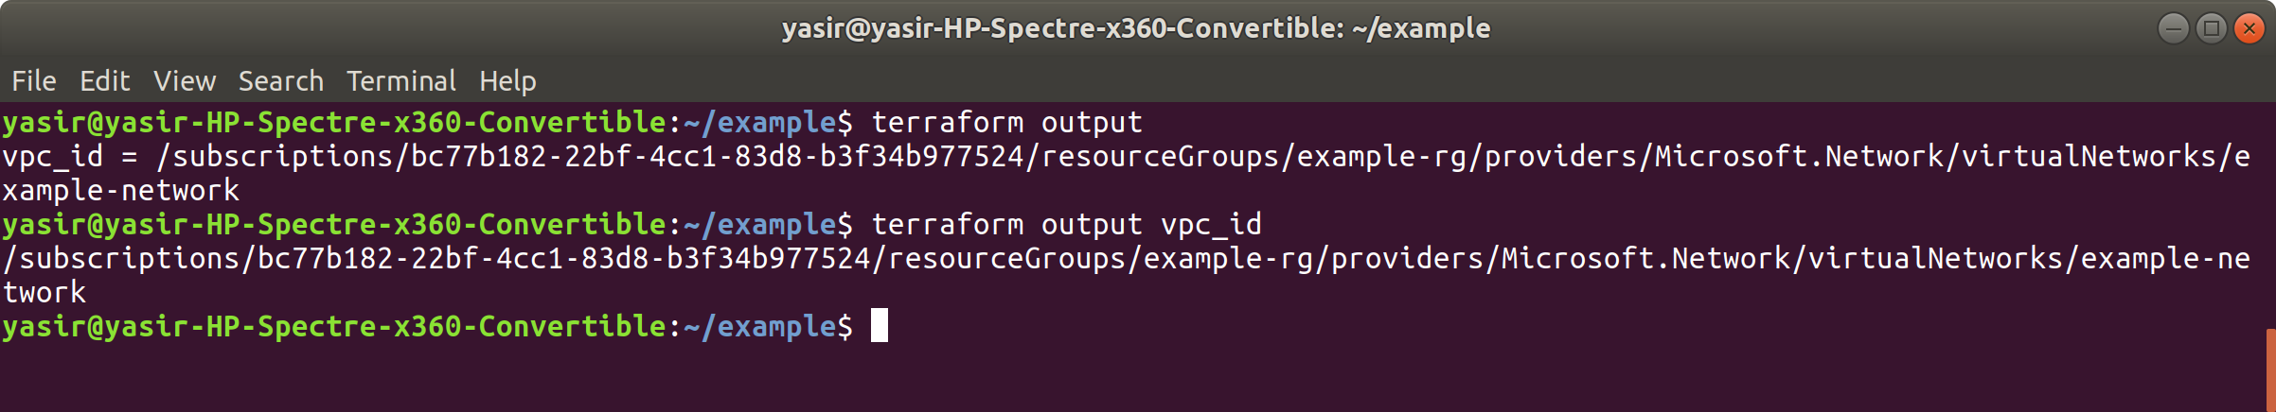

check on Azure portal

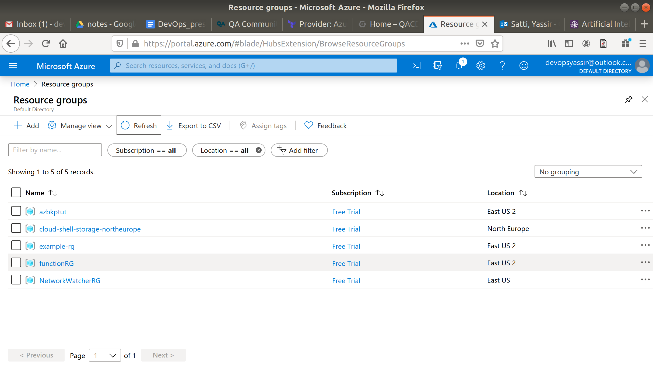

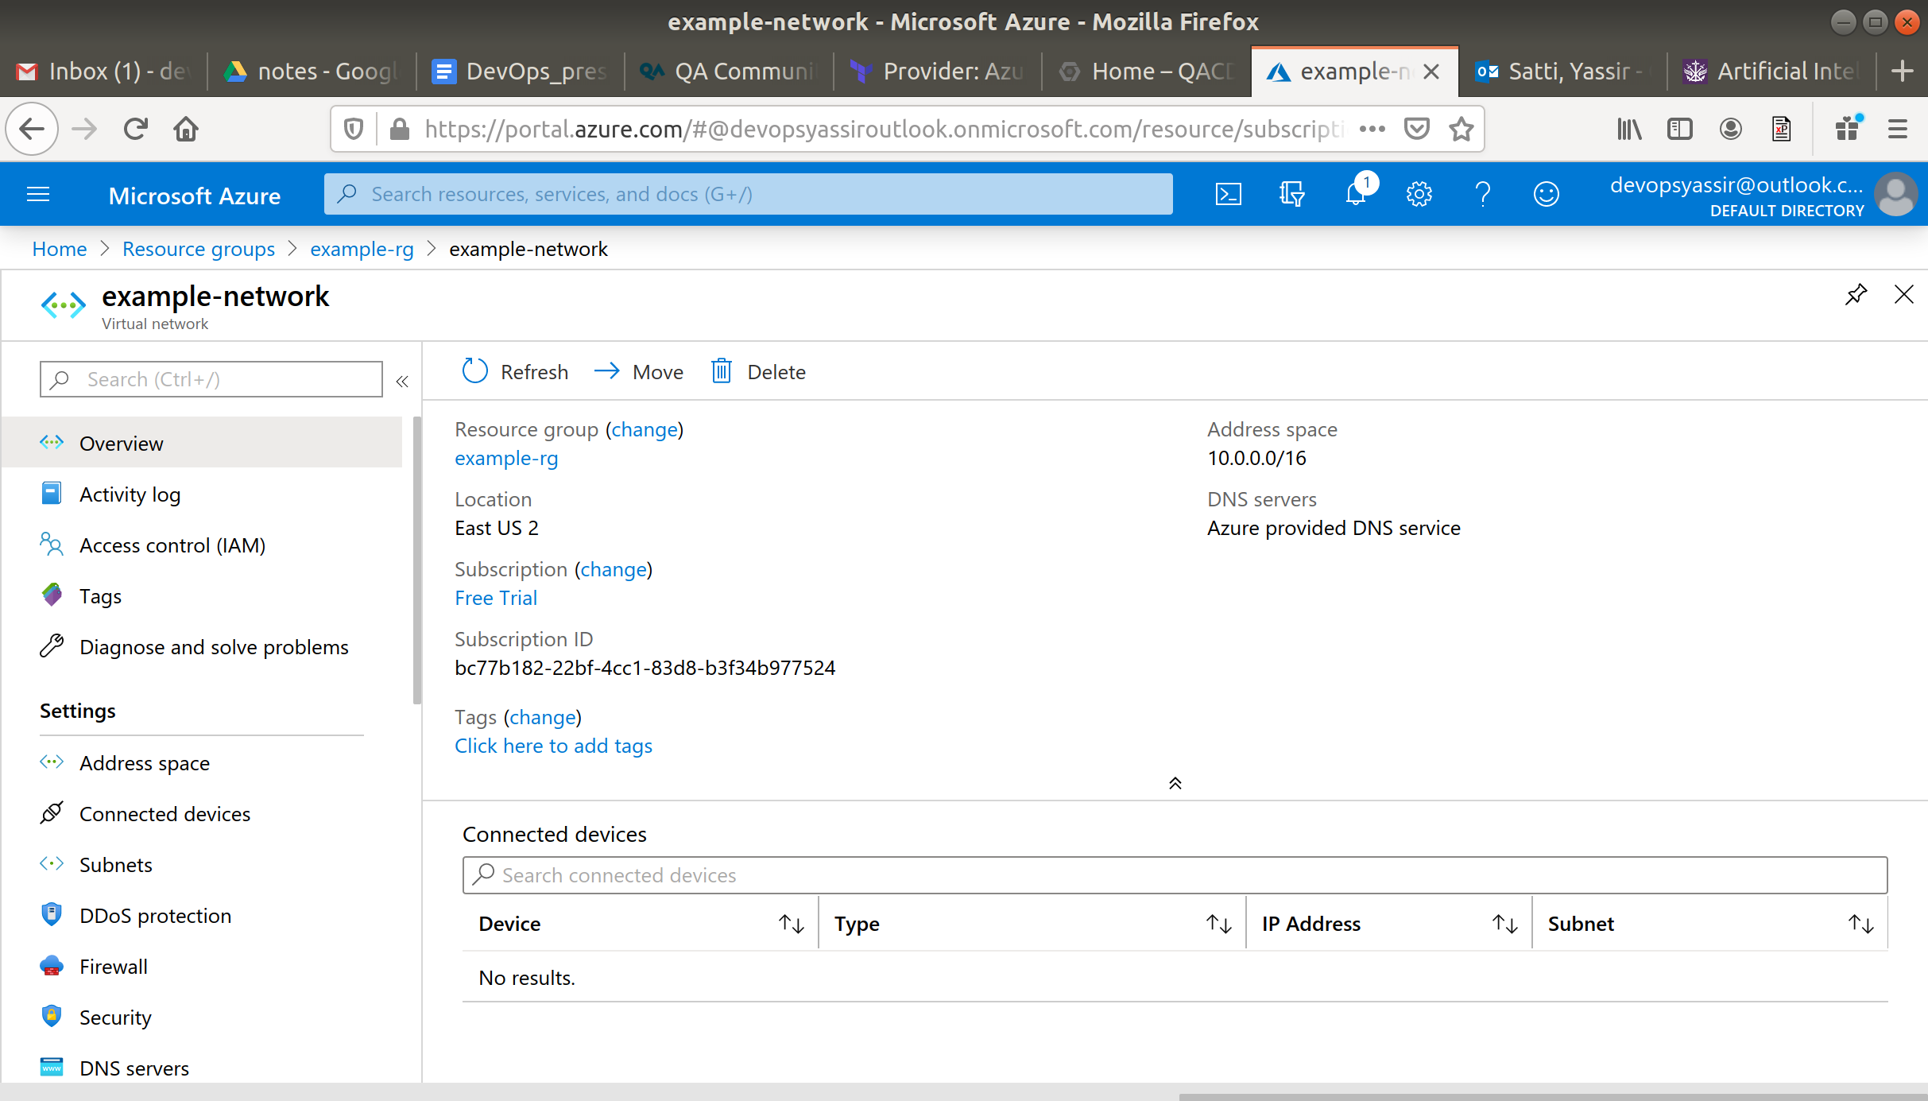

You can format the files, for example, to confirm to Python convention of indentation

**$ terraform fmt**

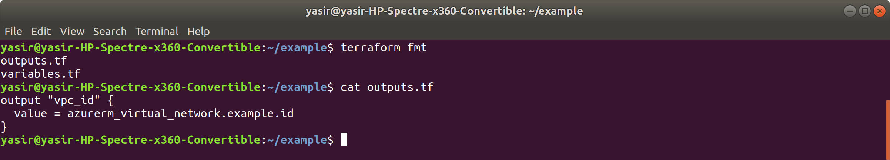

**Clean up**

**$ terraform destroy**

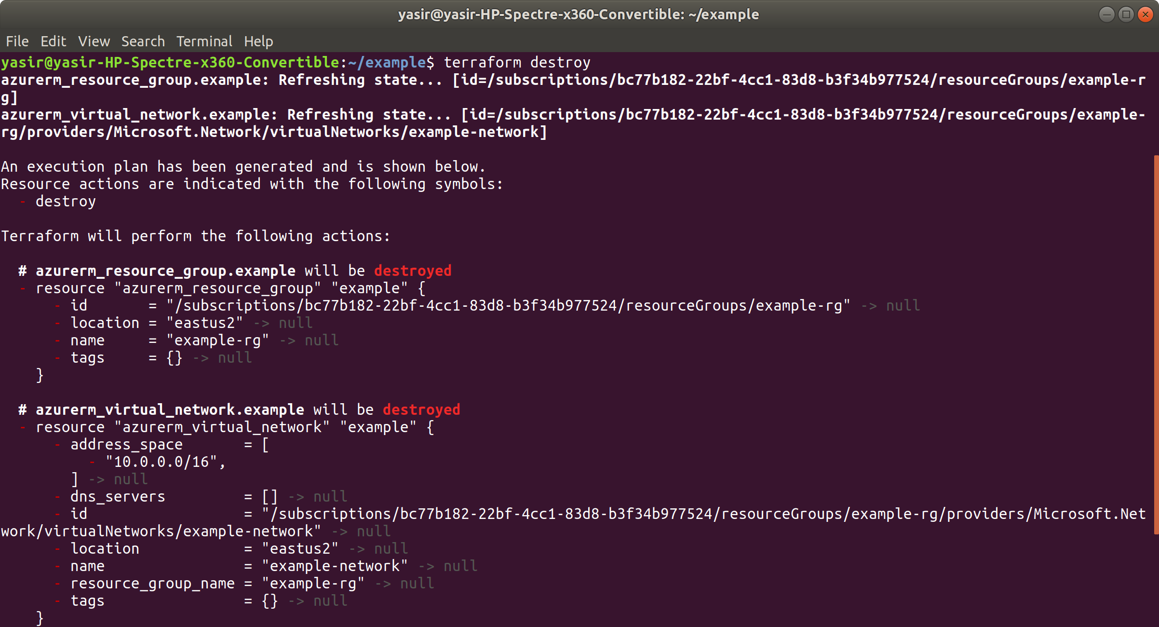

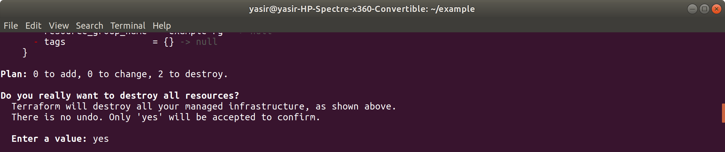

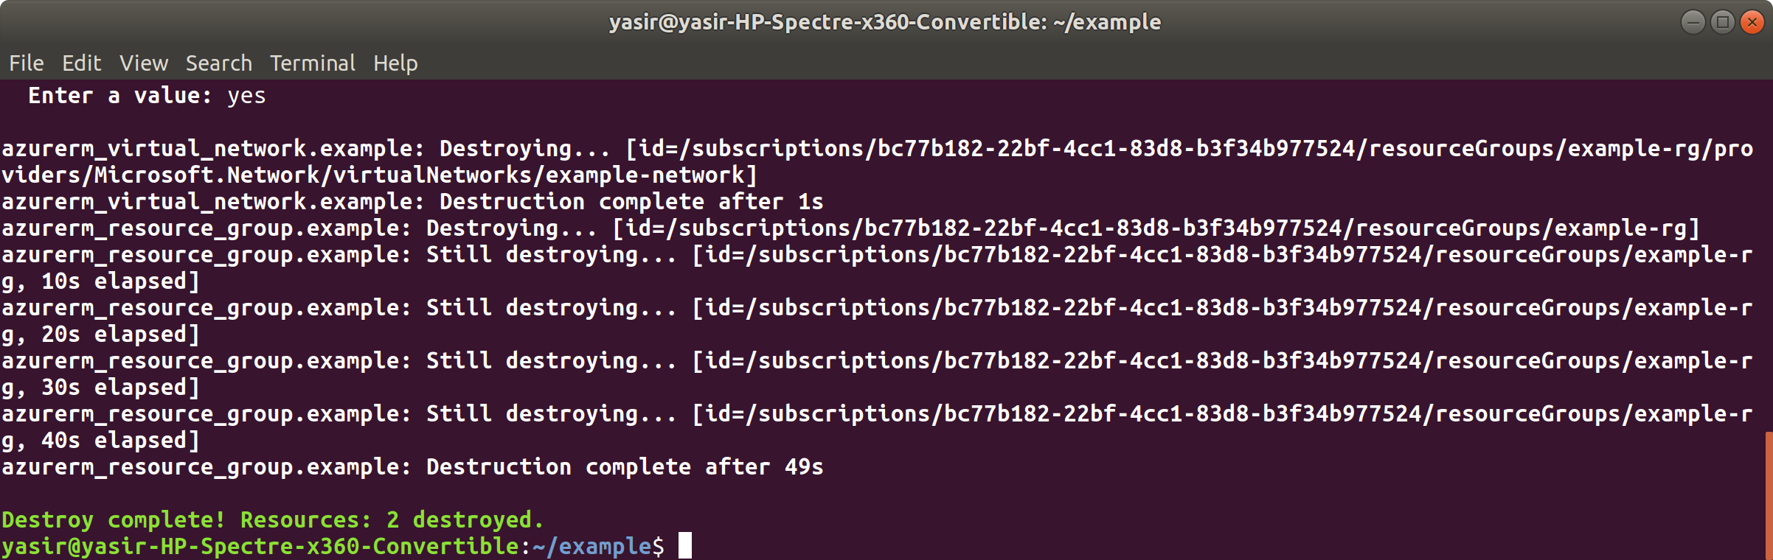

check on Azure portal

